Studio PDR Planning Worksheet
Learning outcome 1
Analyse user requirements to inform technical project work and produce user-centric functionality.
Objectives:
- Capture project requirements in the form of User Stories
- Contribute in a meaningful way to coding and releasing features that meet the user requirements
- Demonstrate an iterative approach to project work using Design Thinking techniques
- Participate in code review to ensure high-quality outputs

Learning outcome 2
Employ ethical and sustainable development methodologies and tools in a team environment.
Objectives:
- Communicate within a team in order to maintain sustainable productivity
- Use industry-standard communication and project management tools in a professional manner
- Contribute to producing safe, accessible, usable and useful software
- Employ leadership and conflict management techniques to sustain an agreed workflow

Name: Logan J. Olding
Date of scheduled PDR meeting: Mid-semester/ Final
Discussed with:

What are your personal goals and objectives in addition to the course objectives?
This could be for Studio, BIT or general career progression
What has gone well this semester? What are your strengths?
What could have gone better and how? What would you do differently next time?
If you could replay the semester over again, what improvements would you make?
What are the next steps to take? What is your plan for further self-development?
What barriers to your success exist? How do you plan to deal with them?
What is not clear or is uncertain?
In Studio, for BIT, at Polytech etc
What evidence do you plan to use to demonstrate your completion of the objectives?
(For the mid-semester PDR you will have only completed some of the objectives. Just bring evidence of those ones)
Add links, screengrabs and/or brief explanations under each objective below. Keep in mind that this should be enough evidence for someone who doesn’t know you to be able to tell that you passed each objective (together with your lecturer’s observation notes).

Capture project requirements in the form of User Stories
e.g. Links to your best user stories in the project backlog
https://github.com/BIT-Studio-3/project-25-2-git-er-done/issues/78

Contribute in a meaningful way to coding and releasing features that meet the user requirements
e.g. Links to Pull Requests showing the contributions you are most proud of
https://github.com/BIT-Studio-3/project-25-2-git-er-done/issues/82
https://github.com/BIT-Studio-3/project-25-2-git-er-done/pull/84

Demonstrate an iterative approach to project work using Design Thinking techniques
How have you been iterative this semester? What improvements have you made?

Participate in code review to ensure high-quality outputs
e.g. Links to PRs where you have written constructive criticism in a code review
https://github.com/BIT-Studio-3/project-25-2-git-er-done/pull/39
https://github.com/BIT-Studio-3/project-25-2-git-er-done/pull/30

Communicate within a team in order to maintain sustainable productivity
Have you been Agile this semester? Have you been a good team member?

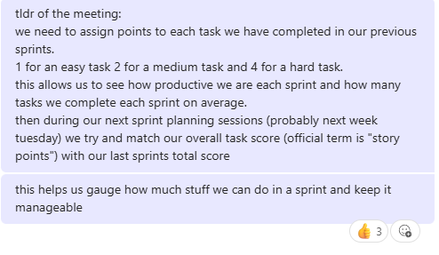

Use industry-standard communication and project management tools in a professional manner
e.g. Have you had a strong presence on GitHub? Have you been proactive in the project?

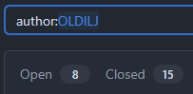

Contribute to producing safe, accessible, usable and useful software
e.g. Show evidence that you have made accessibility/privacy/security improvements or suggestions

Employ leadership and conflict management techniques to sustain an agreed workflow
e.g. Did you adhere to the group’s agreed processes? Did you encourage using Scrum properly?
